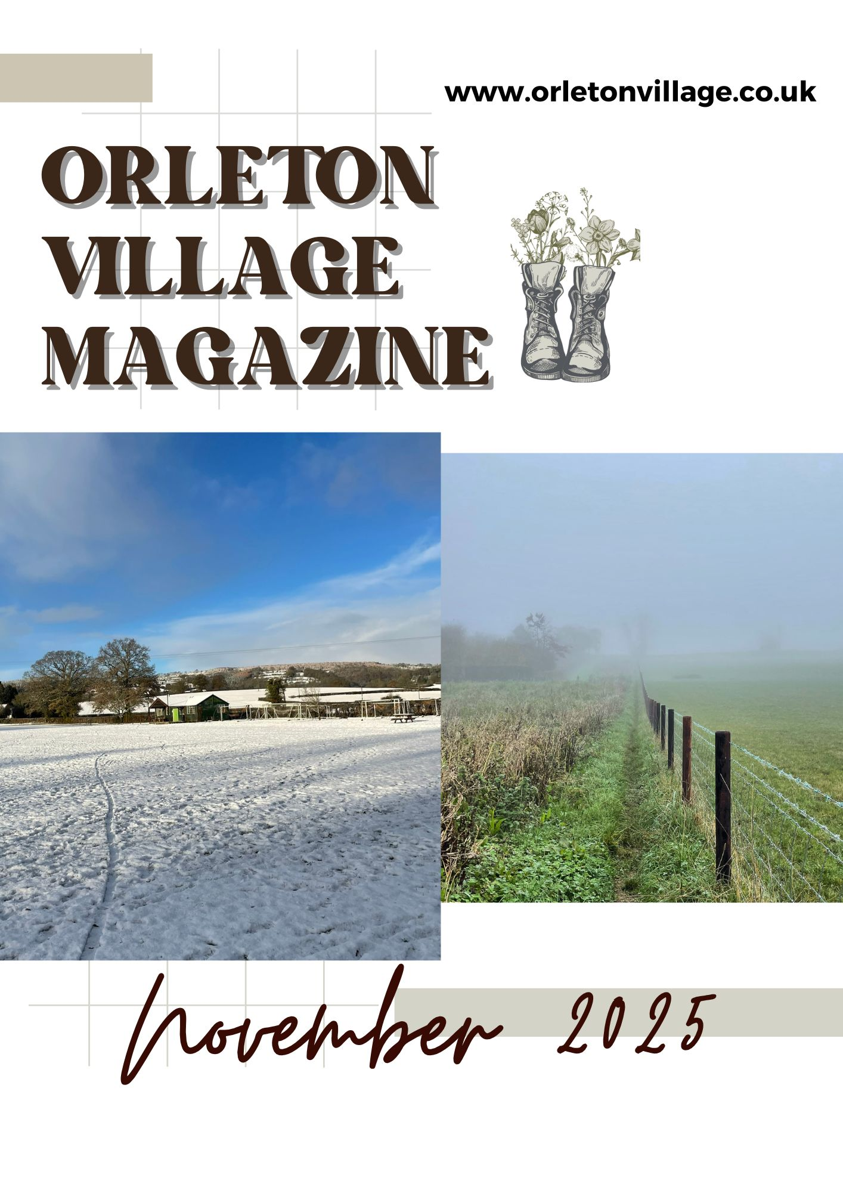

How to be included in

Orleton Village Magazine

This magazine will be published on the first day of each month on the Village Website: *www.orletonvillage.co.uk.* Notification of publication, together with a link, will be given on Nextdoor and Orleton Village Chat (Facebook)

Articles of general interest, club or association reports and advertisements for community events may be included without charge. Commercial advertisements are charged, dependent on size. (Rates available on request from: orletonmagazine@gmail.com)

Small private sale advertisements may be accepted without charge if space allows

**Orleton Village Hall**

**Ideal venue for family events, parties, weddings, concerts, dances,**

**training courses, drama performance, exhibitions, classes and craft fairs.**

**Large hall (160 seating capacity) with proscenium stage, theatre lighting and sound system, electric piano, video projector and radio mike.**

**Additional small hall (50 capacity)**

**Superb five star rated kitchen, cutlery and crockery. Large car park.Free Wi-Fi**

**Also tables, chairs and marquee available for hire for garden parties**

**For bookings /quotations: bookings@orletonvillage.co.uk**

**Tel 01568 780583**

All content is accepted at the discretion of the editorial team. Articles that are disrespectful or prejudicial will not be accepted.

Copy should be submitted as Word or PDF files. If hard copy is submitted there may be a charge for scanning and input.

All copy must be accompanied by the name, address and telephone number of the author, although this will not be included unless incorporated into the article.

Articles for publication should be emailed to: orletonmagazine@gmail.com by the 20th of the month prior to desired publication

**Editorial**

**Orleton Village Hall**

**Ideal venue for family events, parties, weddings, concerts, dances,**

**training courses, drama performance, exhibitions, classes and craft fairs.**

**Large hall (160 seating capacity) with proscenium stage, theatre lighting and sound system, electric piano, video projector and radio mike.**

**Additional small hall (50 capacity)**

**Superb five star rated kitchen, cutlery and crockery. Large car park. Free Wi-Fi**

**Also tables, chairs and marquee available for hire for garden parties**

**For bookings /quotations: bookings@orletonvillage.co.uk**

**Tel 01568 780583**

**This Is the first edition of what we hope will be a monthly electronic magazine for Orleton Residents. It is not intended to replace Grapevine as there will be many who are not online who will still rely on that publication. This magazine is intended for those whom Grapevine does not reach but are on the internet.**

**I recently read an article which differentiated between living in a village and being part of a village. The author commented that there are those that live in a village but are not engaged in the community. They do not participate in village events, visit the village pub and shop at the nearest supermarket buying nothing in the local village shop. They could be living anywhere—village, town or city.**

**However, there are others that move into a village and feel that it is a closed community not open to outsiders. We have new homes in the village, with more to come, bringing new families into Orleton. Let us make it clear that Orleton clubs, societies, Church, associations and sports groups enthusiastically welcome new members. Come and join us, support our events, make new friends.**

**Folk at the Boot**

Not just folk but all genres

of music

Performers always welcome



It's always 2nd Thursday of the month at 8.00pm

**Coffee Morning**

**Village Hall**

10.30 am until noon on Wednesdays

(Not July nor August)

Tea, coffee (incl decaf), Hot Choc

Selection of cakes

Plenty of friendly chat

Everyone welcome—just turn up!

Library visits once per month

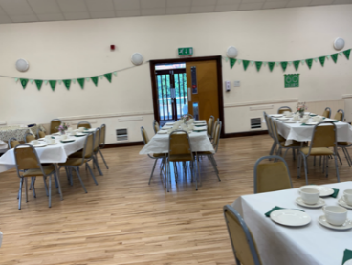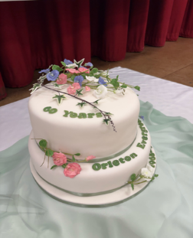Orleton Evergreens

**Orleton Evergreens is a local community group for senior citizens (50+), formed in 1965,**

**we celebrated our 60th anniversary with a catered afternoon tea, cake and bubbly in June this year, attended by over 90 past and present members and guests.**

**We meet on the last Thursday of the month in Orleton Village Hall, 2:30pm when we have a speaker, followed by tea and cake. In the summer months we enjoy outings to a variety of locations. Our Christmas meal and Spring Lunch are always very popular too.**

**Membership is currently £10 per year (payable in January) and £3 per hall visit or visitors can pay £5 per session.**

 Further details please contact: sue.a.turner@gmail.com

Tel: 07840 023856





**Your**

**Advertisement**

**Here**

Only £15 for twelve months

Half page only £20

Send copy to:

**Orletonvillagemagazine@gmail.com**



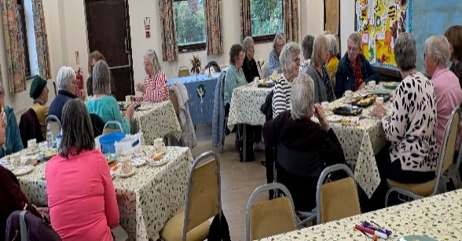**Orleton WI**

Orleton WI meets on the second Monday of every month (except August) in Orleton Village Hall -   
2:30pm in Autumn and Winter,   
7:30pm in Spring and Summer.

Visitors are always welcome.

Our speakers cover a wide range of topics; this year we have heard about the rigorous training of a guide dog, flower arranging, the work of the Leominster Food Bank, a workshop making Dorset Button keyrings and we had an outing to Pitter Potter in Tenbury where we decorated our own piece of pottery, we then moved a few yards down the road for a cream tea at The Spotty Dog.

We also enjoyed our annual Strawberry Cream Tea in August; October’s meeting saw us playing Bingo and enjoying a delightful Harvest Tea. There’s a bit of a theme going on here!

Quarry Farm Shop

**We are providing what you really want…**

**Additive Free Meat**

**Meat as it used to be produced**

**We use traditional methods to produce what can**

**only be called real meat.**

**Between Leominster & Luston on the B4361**

**Telephone 01568 613156**

**Email: sales@quarryfarmshop.co.uk**

**Richard@quarryfarmshop.eclipse.co.uk**

We are planning to take part in the Herefordshire County Show, entitled ‘Autumn Bounty’, at the end of October. In November Orleton WI is again providing refreshments at the Handmade & Gift Fair and also taking part in the Stars & Angels event at the church in December. We are very much part of the community!

Next month, on 10th November at 2:30pm, we welcome Heidi Caldicott talking about Reiki & Reflexology.

If you would like further information, please contact our President,

Sue Copson on

01568 780956 or susancopson934@gmail.com

**Orleton Recreation Association**

We are delighted that ORA is part of the new digital Orleton Village Magazine. It is a tremendous initiative. Just so that as many people can hear about our news, we will continue to publish in Grapevine and on our own FB page.

There are a couple of pieces of exciting news from us this month. First, after some 22 years since it was first mooted, the pavilion re-build project has been completed. We are now starting the next phase to finalise it for a grand opening that – as of today – is scheduled to be Sunday December 14th. We will have a couple of trial events before that date to make sure everything works.

We are now sourcing flooring and white goods to install and there is a fair bit of top-coating to

do but we are absolutely delighted with the work that has happened, which has transformed the building and created another really useful community space.

We will also be planting a new hedge to the south of the Rec. Alisha Davidson did a brilliant job of getting the Woodland Trust to donate about 100 metres of hedging, which will include varieties such as hazel, blackthorn, crab apple, elder, dog rose and rowan and we also hope to add some specimen trees to the mix. We are hoping to organise a planting session when we receive the pack.

If you have any questions about the Rec, please don’t hesitate to contact us by email at:

grahamjbshaw@gmail.com

The ORA Committee

**Traditional**

**16th Century timbered inn,   
now owned by the local Orleton Community.**

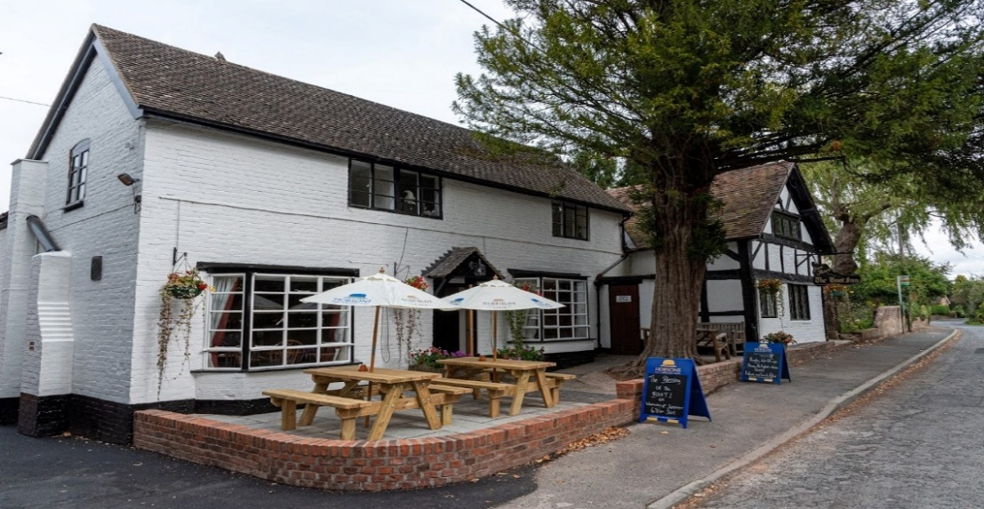

**Offers:**

· **a fine dining menu using the best seasonal produce in its atmospheric beamed dining room**

· **a wide selection of wines**

· **a range of real ales, ciders and craft gins and other spirits**

**Large Beer Garden with Pergolas**

**Large Car Park at rear**

**Reservations: 01568 780228**

**Boot Inn**

**Orleton Charity Quiz Nights**



A family run business with over 50 years of combined experience.

From our house to yours.

Installing ∞ Repairing ∞ Maintaining

Complete Bathroom Renovations & Installations

Annual/One off Boiler Servicing ∞ Natural Gas ∞ Oil ∞ LPG

Electric Underfloor Heating ∞ Tiling/Wet Walling

Break Downs & Emergencies

[bpplumbingandheating@outlook.com](mailto:bpplumbingandheating@outlook.com) 07967856051

BP & Son

Plumbing and Heating LTD



**Teams of up to six members. 7.30 for a 8.00pm start**

**Pre-booking of tables at the Boot (01568 780228) and the Maidenhead (01584 831686)**

**is strongly advised**

March 10th Village Hall

April 14th Maidenhead

May 12th Boot Inn

June 9th Village Hall

November 11th Boot Inn

December 9th Village Hall

January 13th Maidenhead

February 10th Boot Inn

**All proceeds go to support local organisations in Orleton Village or**

**recognised National Charities.**

**Special Event: John Robbins Memorial Quiz at Orleton Village Hall**

**on a Saturday evening. Watch for the date!**



**Report from your County Councillor**

**Dan Hurcomb**

The end of the year is certainly coming on fast and life continues at a hectic pace at the moment with lots of local issues coming to the boil at the same time.

**Road Works**

We have been lucky in recent months to have had resurfacing at the B4362 at Comberton, the Kings Road in Orleton, the B4361 at the Luston turn and the B4362 between Yarpole and Lucton. This has made a huge difference locally and I am pleased to say that in addition to this the B4361 between Portway and Richard’s Castle will undergo extensive patching work in November.

**Road Safety**

This month has also seen the installation of the “20 when lights flash” signs either side of the school. This work and the lining / roundels throughout the village has been paid for from the S106 contribution made by the developers of Captains Meadow. The measures are designed to “calm” traffic and keep local roads safe for all. Thanks go to Cllr Bishop for her persistence in getting this scheme delivered.

**Flood Works**

On the 17th October 2024, Orleton saw the first flood of the “season” which deposited tonnes of silt in Milbrook Way. The severity of this event and the frequency of events in the months that

followed has led to further development of flood resilience schemes and I am pleased to report that we now have three potentially viable options on the table

which if delivered together could resolve some of the long standing flooding issues the village faces. There isn’t space to list details of all three here but please do get

in touch if you would like to hear more. I would like to take this opportunity to thank the Parish Council and Cllr David Lane in particular for their support in getting us this far.

**Finance**

In less good news, there has been a worrying development with regard to the Council finances in the last month or so. This is as a direct result of the information we are receiving from central government regarding our funding for the next financial year as part of their “Fairer Funding Review”. At the moment our current analysis of the financial situation suggests that once the increased demand for services is taken into account the difference between what the council requires and what the council will received (from Government and Council Tax) Is nearly £28million which will rise to over £120m by 28/29 if no action is taken. This pressure relates to the revenue budget but it is clear that the task that faces all of us is tough and significant and painful decisions lie ahead. I will of course keep you updated as and when more information on what this means becomes available.

At the October Council meeting took I was pleased to support three motions at which called for:

1. The Police to reconsider their decision to stop local Police Community Support Officers working after 8pm

2. To promote a “child friendly” Herefordshire, and

3. To investigate cheaper travel for 16-19 year olds on Herefordshire buses.

As always if you have any concerns, issues or would just like a chat then please do get in touch.

**Dan Hurcomb 07837726821**

**dan.hurcomb@herefordshire.gov.uk**

**Contact Dan:**

**Email: dan.hurcomb@herefordshire.gov.uk**

**Tel: 07837726821**

HITREES Ltd.

**~** Est. 1987 **~**

**Landscaping & Groundwork Contractors**

**Mini Digger & Compact Tractor Hire**

**With Driver**

**Contact:** Ian Godding

**Mobile :** 07885 839348

**Office:** 01568 780496

**Email:** hitreesltd@gmail.com

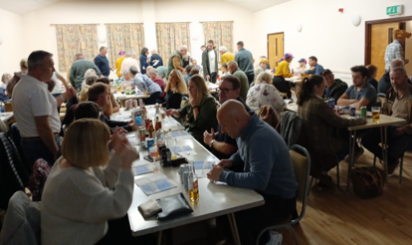

Race Night at Village Hall

Saturday 18th October saw the return of the ever-popular Race Night at the Village Hall. This event in support of the Village Hall and the Apperley Recreation Ground attracted a large attendance and generated a great deal of both fun and funds.

Grateful thanks go to the Race Sponsors: Samuel Wood Estate Agents, The Boot Inn, Orleton Gardening Club, The Maidenhead Inn, B & P Powell Plumbing & Heating, Orleton Table Tennis Club, Teme Valley Electrics, Orleton Village Shop & Post Office and Graham Jenkins.

Some of the above also supported by advertising in the Race Programme as did Victoria Allen, Endless Travel, Minster Auction, Quarry Farm Shop and Alf Jenkins.

Thanks also go to the Maidenhead Inn for the donation of a meal for four with drinks, which when auctioned raised a substantial sum.

Our appreciation also goes to the Compare, the Tote Team and the Kitchen Team, who produced a very tasty supper



**Orleton History Group Update**

Our September event was a wonderful exploration of agriculture over the centuries. Over 100 people enjoyed seeing and trying out traditional crafts such as spinning, peg-looming, and needle-felting; working out where their house was on an 1840s map; viewing a vintage tractor and some less vintage sheep; reading some fascinating information boards; nd visiting the Cider Barn. We also had some wonderful quiz entries with amazing needle-felted and peg-loomed prizes. Our October event on the History of Church Music is yet to take place as I write.

We have also been undertaking a project, researching the lives behind the men on the War Memorial, under the leadership of Ann Turtle and kindly funded by the Parish Council. To see the profiles completed so far, please see:

**https://stgeorgesorleton.org.uk/ and click on Orleton History Group.**

Our upcoming talks & events are below. The talks are all free, donations invited for refreshments & heating.

**Saturday 29th November**, 2.30-4pm, St George’s Church: 900 Years of Faith: James Forrester will explore the subject of: A Parish Church? Yes, but why? And how well does such a church help us in our responsibility to share the good news of the Kingdom of God?

**Saturday 13th December**, 7.30pm, St George’s Church: From Minced Meat to Mincemeat, the strange story of the mince pie, accompanied with Christmas wines: sample a range of mince pies from across the ages, starting with the original savoury minced meat pies and ending with our current sweet pies; all washed down with some of the choicest wines of the age! To allow us to cater (and purchase wines) for appropriate numbers, this is a ticketed event. Tickets £5 if purchased by Sunday 8th December from the Village Shop. £8 if purchased on 9th December or later.

You can also read reports on previous talks at the history group page at: www.stgeorgesorleton.org.uk (and then click on ‘activities’ and then ‘Orleton History Group’).

If you would like further information about the group, please contact Liz Mackay on

**e.e.mackay@gmail.com, or 07484 679671.**



.



 **ORLETON AND DISTRICT GARDENING CLUB**



**Propagation: From Seeds, Cuttings and Division**

 On September 30th we welcomed back Philip Aubury, former Director of Birmingham Botanic Garden, to give a practical demonstration.

**Seeds** Philip advises looking out for F1 hybrids and seeds which have been awarded the RHS Award of Garden Merit (AGM). Using a fine compost the tray is filled and tapped down firmly. Half an inch of compost is sieved on top. Fine seeds, for example foxglove and begonia are surface sown, medium sized seeds like lettuce are covered with a light sprinkling of compost which he prefers to vermiculite. Large seeds are sown in 3 inch pots, six peas or two beans per pot. Containers are gently watered from above and placed in a propagator. After the first pair of true leaves develops seedlings are pricked out into cell trays, handling them by the seed leaves to avoid damage. They are planted so that the seed leaves rest on the compost surface.

**Cuttings** Philip uses a mix of ¾ multipurpose compost and ¼ sharp sand. Demonstrating with pelargoniums, tip cuttings are detached just below a node (nodal cuttings), stripped of all but two or three leaves and dipped into rooting powder before being inserted around the edge of a small pot. They are watered and covered to reduce transpiration. Internodal cuttings, cut midway between two nodes, work better for fuchsias, clematis and hydrangeas.

Begonias and African violets are propagated by leaf cuttings. A begonia leaf is detached cleanly, the veins on the underside are cut through and the leaf is laid flat in a seed tray of compost topped with horticultural grit and weighed down lightly. Plantlets will develop from the cut veins. African violets are propagated by detaching a leaf cleanly from the base with one inch of stem, dipped in rooting powder and inserted into pots.

Hardwood cuttings, usually taken in autumn, useful for many shrubs including Salix, Cornus and roses are taken by selecting 12 inch long pencil thick stems cut below a node and inserted into tall narrow pots and left in a sheltered position outside

**Division** Useful for many herbaceous perennials. Philip advises dividing perennials grown on heavy soils in Spring and those on light soil in Autumn.

Like the best television chefs Philip brought ‘dishes’ prepared earlier to whet our appetites and inspire us, an economical way to increase stock for our gardens and our annual Plant Sale.

*Ghislaine Arundale*

**On Tuesday November 25th Nancy Lowe’s talk is ‘Wildlife Gardening’.** As a RHS qualified organic gardener, ecological garden designer and permaculturalist she will takes the mystique out of this rewarding pastime, offering clear steps you can take to add wildlife benefits throughout your existing garden.

**Doors open 7.15pm for 8pm start. Non-members welcome at £2.50 per person which includes tea or coffee.**

**Annual Membership £15.0**

**www.orletongardeningclub.co.uk**

**Mortimer Practice Patient Participation Group**

**The Total Triage System has gone live from 1st October 2025**

A Total Triage system is a patient pathway, where all patient requests for appointments or advice are reviewed and triaged by clinical staff before an appointment is assigned. This process uses a combination of digital and traditional methods to gather information, ensuring patients receive the most appropriate care - whether that's self-care advice, a telephone consultation, a face-to-face appointment, or a referral to another service - and reducing pressure on phone lines.

How it works:

**Information Gathering:**

Patients submit their requests using digital forms, online systems, or by speaking to a receptionist.

**Clinical Review:**

A clinician reviews the submitted information to determine the best course of action.

**Appropriate Pathway:**

Based on the review, the patient is directed to the most suitable service, which could include:

· Self-care advice

· A telephone or video consultation

· A face-to-face appointment with a GP or other healthcare professional

A referral to another service, such as a pharmacy or specialist

Benefits:

**Improved Access:**

It aims to reduce waiting times for those who need to call the practice by encouraging more patients to use the digital route.

**Better Quality of Care:**

Patients receive timely advice and access to the most appropriate care for their specific needs.

**Efficiency:**

The system helps practices manage patient requests more effectively, freeing up time for staff to assist those who need more help or prefer to call.

**Reduced Footfall:**

It helps reduce unnecessary visits to GP practices, which is particularly important for protecting both patients and staff from infections.

In essence:

Total Triage is a system designed to get patients the right help at the right time, using digital tools to streamline the process and ensure safe, effective care. Patients without digital access are asked to contact reception either by phone or in person at the surgery, and the team will complete the request on their behalf. The Practice is also installing iPads in each surgery so that patients can come in and use them if they prefer, with staff on hand to provide support.

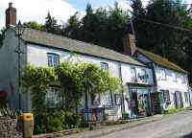

Orleton Village Shop

& Post Office

Shop Post Office

Mon- Fri 0745-1800 0745-1800

Sat 0830-1230 0830-1230

Sun 0830-1230 Closed

**Debbie Gates**

**07966 061205**

**Professional Painting & Decorating**

**Interior & Exterior**

**Airless Spraying**



Foundations Excavations

Site clearance Concrete work

**Edward Royle**

**JCB Hire**

**All types of groundwork**

Small jobs undertaken

01584 831418

07890 136426

Concrete breaking

Drainage/Septic tanks Driveways/pools







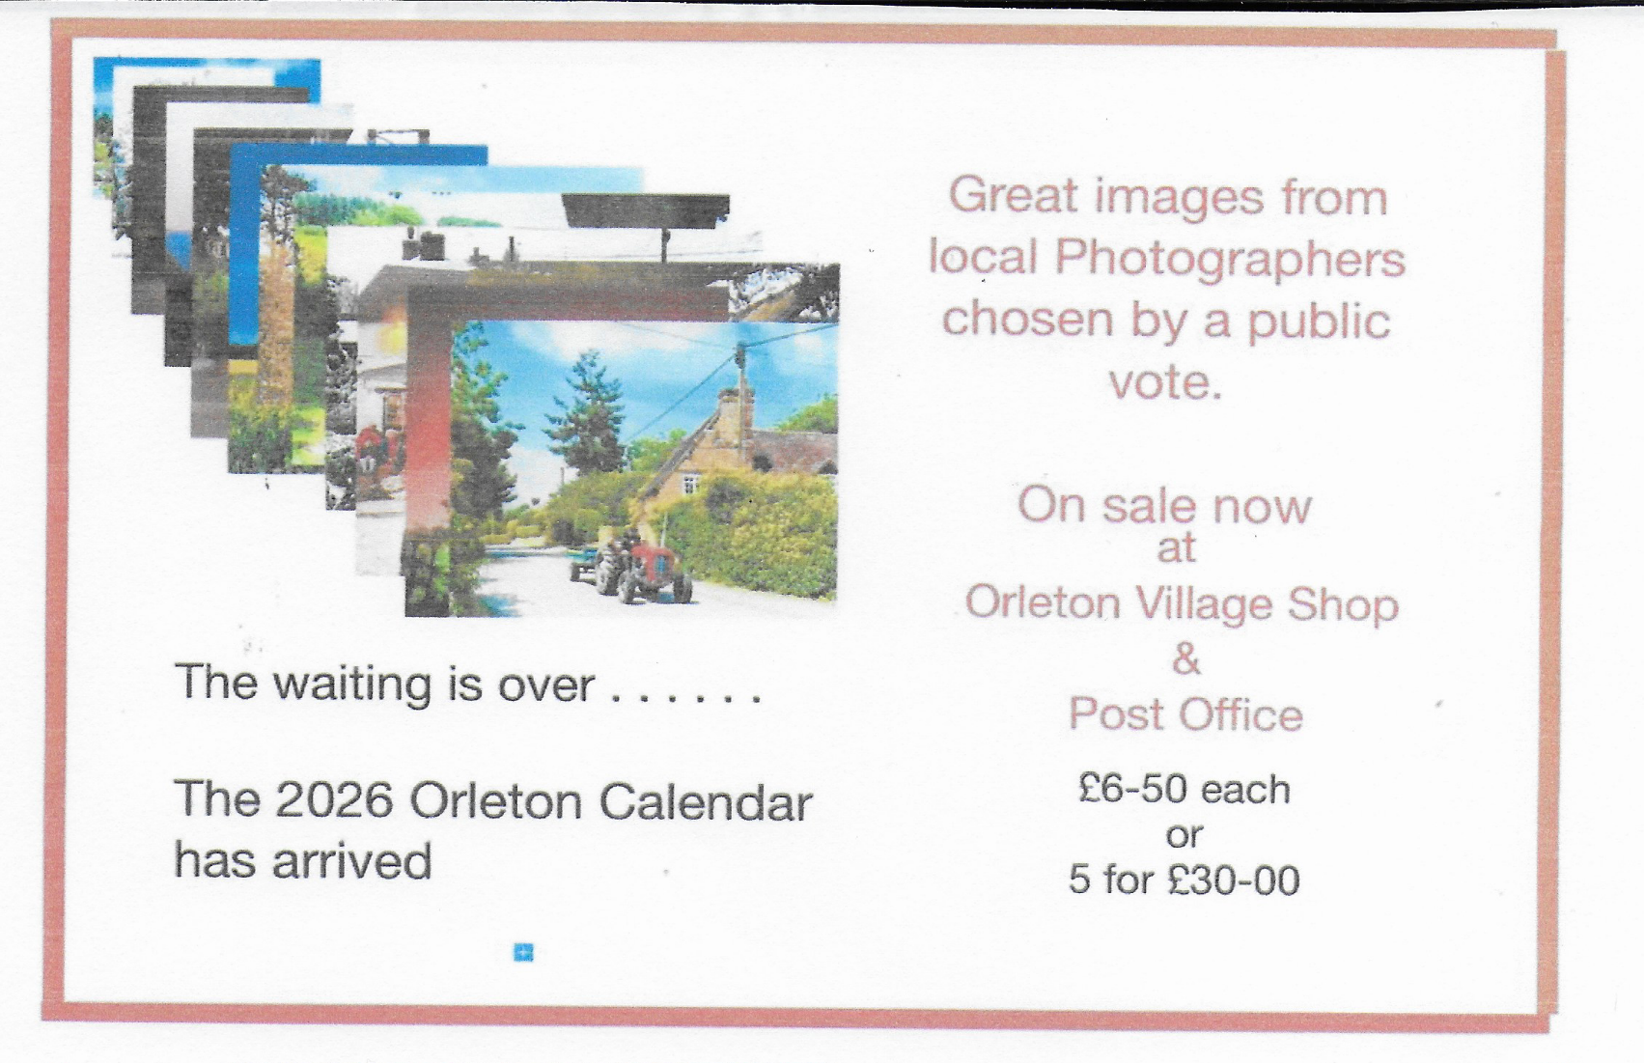

Orleton Church & Chapel News

The key event this month is Remembrance Sunday. The Remembrance service is on Sunday 9th November, starting at 10.45 at the War Memorial, and continuing in St George’s Church around 11.15. Join us for a traditional Remembrance Service as we remember in words and music the sacrifice of those who died so that we can live in freedom from fear and oppression.

Last month, we were delighted to join with the Village Hall and the Recreation Ground in celebrating our Harvest Festival. We had a service

in the Village Hall, followed by a wonderful lunch.

We were also thrilled with the super atmosphere at our still fairly new Family Services. These services are for people of any age who prefer a more informal style of worship, and take place on the

second and fourth Sundays of the month, at 3pm – see elsewhere in this magazine for details.

Updates on our other activities, including ongoing church and churchyard maintenance, the Orleton History Group, Singing for Fun, support for the Village Coffee Morning, Caring for God’s Acre, food bank donations, and the 100 Club winners, can be found in our full newsletter, at:

**https://stgeorgesorleton.org.uk/news** , and click on ‘**Church & Chapel News’**.

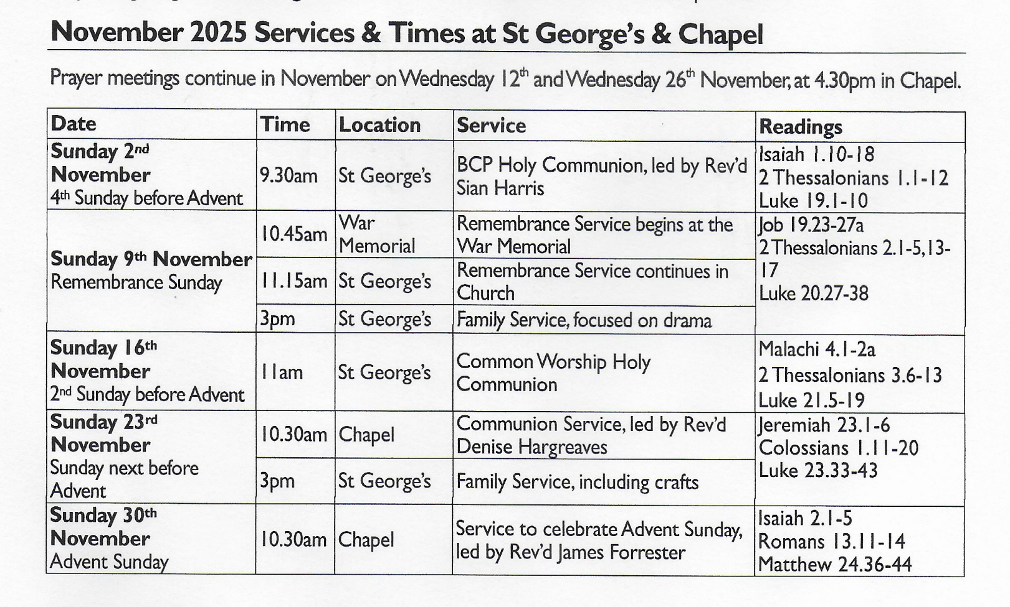

Further information

For further information about Church, Chapel, services or activities, or if you would like to get involved either socially or as a member of the congregation then please contact:

Matthew Burns (Vicar, St George’s):

01568 614399, teamvicarwest@leominsterteam.org.uk

Rev Denise Hargreaves (Methodist Minister): 01584 318628, dkah26@gmail.com,

Ludlow Church Office 01584 879233

Also, why not check out the St George’s website: https://stgeorgesorleton.org.uk/



Orleton Good Neighbour Scheme

The Good Neighbour Scheme supports our community using a team of volunteers to help people who are experiencing difficulty in their own homes essentially, by just doing things that good neighbours do for each other.

Examples of how the scheme can help:

* Fetching prescriptions
* Occasional lifts to the surgery or hospital
* Shopping and running errands, such as posting a letter.
* Practical tasks around the home, such as changing a light bulb or hanging a picture

**Contact Number 07467 535503**

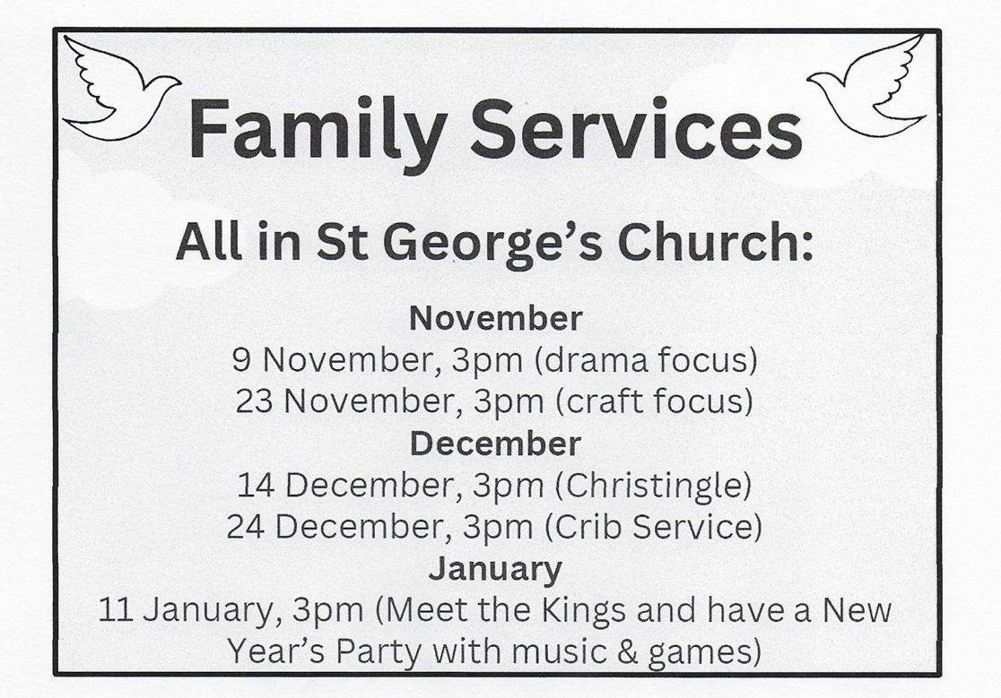



Orleton Short Mat Bowling Club

Every Tuesday at Orleton Village Hall from September through to April. We are a small group who meet each week for a friendly game and the opportunity to socialise.

Everyone is welcome, whether you have played before or would like to learn.

If you think you might be interested please come along and see what the game is all about. We operate on a pay as you go basis. Two games during the afternoon with a refreshment break half way.

For any further information please contact:

David or Sue Copson 01568 780956

Susancopson934@gmail.com

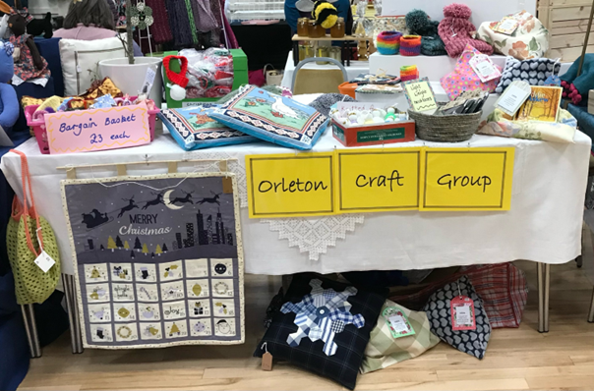**Orleton Craft Gro** **up**

Orleton Craft Group has been in existence for just over ten years. We are a group of like-minded ladies who meet twice a month on the first and third Thursdays,1:30-4:30pm, at Orleton Village small hall, £4 per session. We enjoy a whole range of crafts: knitting, crochet, quilting, embroidery, drawing and much more, offering help and guidance to one another if required.

Tea or coffee and cake is provided and we enjoy a chat along the way! Our stall at the annual Handmade & Gift Fair is always well received. Occasionally we have a workshop or we organise outings to various craft events e.g. the NEC for the Creative Craft Show and Malvern for the Autumn/Spring Quilt Shows.



Visitors are always assured of a warm

welcome.

Further information contact:

sue.a.turner@gmail.com

Tel: 07840 023856

**Orleton Parish Council**

# Street Sweeping Alert

## Tuesday, 4th November

Attention all village residents, especially those of you who are car owners! Street sweeping will take place during the day on Tuesday, 4th November through the village in a radius out from the war memorial, with some preparation also being undertaken the day before. In order to ensure our roads remain clean and tidy and reduce the risk of dry vegetation and debris finding its way into the drains, we kindly ask that you do not park your vehicles on the main roads through the village on these two days, if at all possible.

Thank you in advance for your co-operation in helping us keep the roads clear and supporting our street maintenance efforts!

## Thank you.

Clerk, Orleton Parish Council

Email: clerk@orletonpc-gov.uk

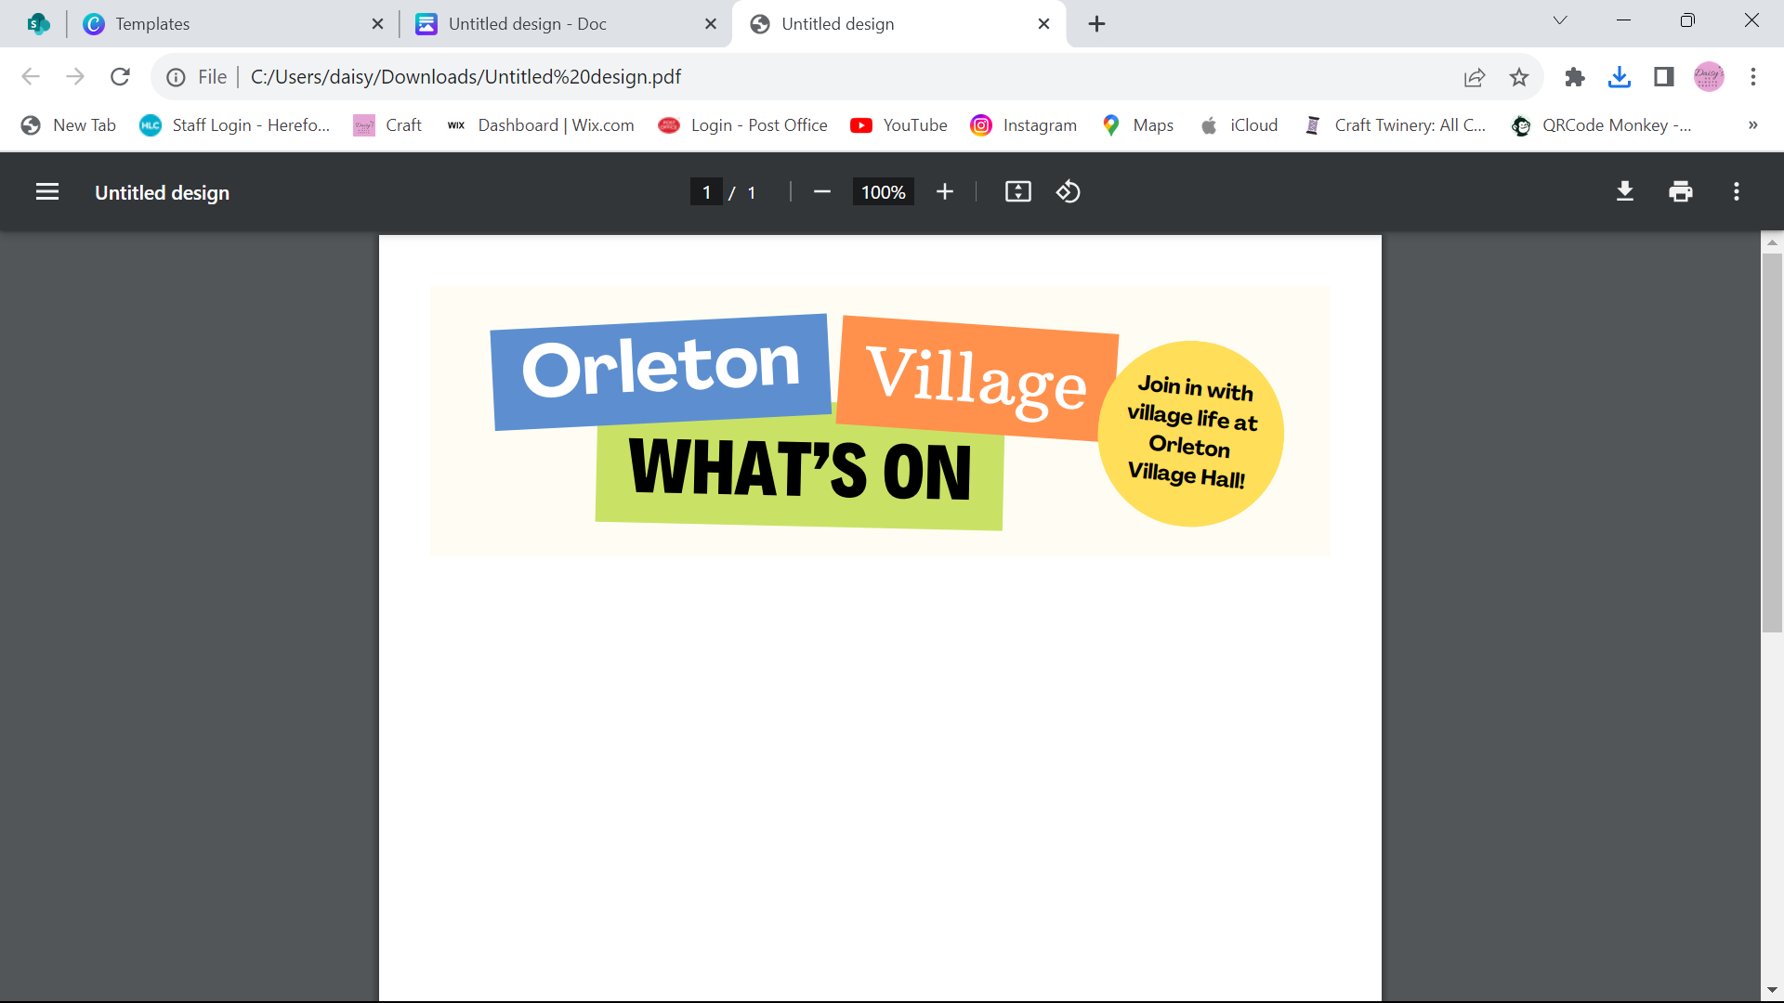

**Orleton Good Neighbour Scheme**

**07467 535 503**

**Do you need a helping hand:**

· **a prescription collected?**

· **a lift to the surgery or hospital?**

· **light bulb replacing, etc.?**

**COMING UP… (All events are in Orleton Village Hall unless stated otherwise)**

**Tuesday 11th November** – Quiz Night 8.00pm at The Boot - £2 entry plus Raffle

**Saturday 15th November** – Orleton Handmade and Gift Fair - Free Entry - Stalls, Music and Refreshments 10am -3pm

**Dates for your diary…**

**Tuesday 9th December** – Quiz Night 8.00pm at The Village Hall - £2 entry plus Raffle

**Saturday 7th March** – Ludlow Concert Band return to the Village Hall

**The REGULARS Monday – Thursday …**

**Orleton Toddlers** Every Monday morning 10-11:45am Contact: Bethan 07534 726222 or

Charlotte 07964 981036

**Orleton WI** 2nd Monday of the month at 7:30pm Contact: Sue Copson

[susancopson934@gmail.com](mailto:susancopson934@gmail.com)

**Pure Fit** Every Tuesday 9-9:45am Contact: Mandy 07538 218273,

[mandyharrison398@gmail.com](mailto:mandyharrison398@gmail.com)

**Tai Chi** **NEW** - Every Tuesday 10:15-11:15am Contact: Rose

**Bowling Club**  Every Tuesday at 2pm Contact: Sue Copson [susancopson934@gmail.net](mailto:susancopson934@gmail.net)

**Rainbows** Every Tuesday in term time 4:30-5:30pm Contact Kaye Harrison

[kayemharrison@yahoo.co.uk](mailto:kayemharrison@yahoo.co.uk)

**Gardening Club** Last Tuesday of the month 7:30-9:30pm Contact: Monica 01568 613361

[orletongc@hotmail.co.uk](mailto:orletongc@hotmail.co.uk)

**Yoga** Every Tuesday evening 6:30-7:30pm Contact Rosie 07834 851656

**Coffee Morning** Every Wednesday at 10:30am-12:00 Contact: Cathy Hardwick

[cathy.hardwick@hotmail.co.uk](mailto:cathy.hardwick@hotmail.co.uk)

**Library**  Last Wednesday of the month Contact: Sue Rogers 01584 831514

**Sequence Dancing** 3rd Wednesday of the month – 2-3pm Contact: Amy Whitby

[amyelwynwhitby@gmail.com](mailto:amyelwynwhitby@gmail.com)

**Evergreens** Last Thursday of the month – 2-4pm Contact: Sue Turner sue.a.turner@gmail.com

**Messy Church** For further information please contact Sara Burnham 01568 780848

[burnmill489@gmail.com](mailto:burnmill489@gmail.com)

**Craft Group** 1st and 3rd Thursday of each month 1:30-4:30pm (No sessions in August)

Contact Sue Turner 01584 831324 sue.a.turner@gmail.com

**Table Tennis** Every Thursday at 7:30pm Contact: Geoff Lewin geoffnlewin@gmail.com

**Village Hall available for private bookings - contact 01568 780583 or** [**bookings@orletonvillage.co.uk**](mailto:bookings@orletonvillage.co.uk)

**To include your event or amend an entry in the Dairy,**

**Please Email** [**orletonhandmade@gmail.com**](mailto:orletonhandmade@gmail.com) **by the 12th of the month**

All entries are, as far as we know, correct at the time of going to print.



**Victoria Allen Funeral Services**

An independent Family Business

Over 25 years of experience

Competitively price

Private Chapel of Rest

Golden Charter pre-paid Funeral Plans

Home visits available

24 hour service

01584 870935

Email: vafs@btinternet.com

9 Charlton Rise, Ludlow, SY8 1ND

www.vallenfuneralservicesludlow.co.uk

**IMS Brickwork**

**We have built a solid reputation for**

**professional, reliable, clean and insured construction**

**Patios, General Brickwork, BBQs Shed Bases, Raised Beds, Repointing**

**Tel: 07840 367845**

**iansimcox@imsbrickwork.com**

**www.imsbrickwork.com**

**Grafted Apple Trees**

**Discovery, Ashmeads, Russets and more**

**Three year old Dessert. Cooking and Cider varieties in pots for easy care until you decide where to plant**

**Root Stocks:**

* **M25 Vigorous**
* **M111 & M106 Semi Vigorous**

**Advice on tree and orchard management also provided**

**Contact Chris:01584 831195**

**Waterloo Farm, Orleton Common,**

**www.applewoodcourses.com**

Order your

**Orleton 2026 Calendar** now!

The Calendar, featuring the winning entries from the Village Photographic Competition is now in production and will be available at a cost of £6.50.

Now available at Village Shop & Post Office

**Contacts**

|  |  |  |  |
| --- | --- | --- | --- |
| Adopt a Footpath Group | Martin Bradford | emimart@hotmail.com | 01568 780151 |
| Allotments Assoc | Nick Ford |  | 01584 875834 |
| Art Group | Geoff Trotter | Geoffrey.a.trotter@gmail.com |  |
| Caring for God’ Little Acre | Barbara Mark |  | 01568 780842 |
| Church Wardens | Liz Mackay  John Berry |  | 07484 679671  01568 780321 |
| Cubs | Lisa Davies |  | 01584 831356 |
| Dance Fit | Pauline Woodward |  | 01568 780950 |
| Doctors |  |  | 01584 831300 |
| Evergreens | Sue Turner |  | 01584 831324 |
| Gardening Club | Nick Russel |  | 01568 780678 |
| Good Neighbour Scheme |  |  | 07467 535503 |
| Herefordshire Councillor | Cllr. Dan Hurcomb | dan.hurcomb@herefordshire.gov.uk | 07792 882147 |
| Land Drainage Group | David Lane |  | 01568 78036 |
| Orleton Relief in Need | Barry Rogers |  | 01584 831514 |
| Orleton Junior Football Club | Mel Williams | cherry.brook@me.com | 07511 920515 |
| Orleton Todlers | Bethan Jenkins | bethan.i.edwards@hotmail.co.uk | 07534 726222 |
| Parish Council |  | clerk@orleton-pc.gov.uk |  |
| Pre-School | Tara Morris |  | 01568 780143 |
| Primary School |  |  | 01568 780366 |
| Primary School PTA | Nicola Goodman | nicolagoodman1989@gmail.com |  |
| Rainbows | Carly Morgan |  | 07788 236628 |
| Recreation Association | Graham Shaw |  | 01568 780783 |
| Village Hall |  | bookings@orletonvillage.co.uk | 01568 780583 |
| WI | Sue Copson |  | 01568 780956 |